NATIONAL UNIVERSITY OF SINGAPORE
EXAMINATION FOR THE DEGREE OF
B.ENG. (ELECTRICAL) / B.ENG. (COMPUTER ENGINEERING)
(Semester II: 2001/2002)

EE4212 – COMPUTER VISION
April / May 2002 - Time Allowed: 2 Hours

Instructions to Candidates:
1. This paper contains FOUR (4) questions and comprises FIVE (5) printed pages.
2. Answer all FOUR (4) questions.
3. All questions carry equal marks.
- This is a CLOSED BOOK examination but candidates are allowed to bring in an A4 sheet of paper.

EE4212 Computer Vision / Page 2

Q.1
A video camera is set up such that it is pointing at the base of a vertical post (Figure 1). A 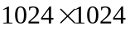 CCD sensor with a photoelement size of 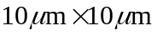 is used as the image sensor. The camera is fitted with a zoom lens which is currently set at a focal length of 35 mm and an aperture diameter of 25 mm. The optical centre of the lens is positioned 3 m above the ground.

- For an object point at the base of the post, what is the image distance, v, and magnification, M?
(4 marks)

- Suppose the height, 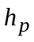, of the post is 0.5 m. What is the length, 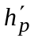, of the image of the post on the CCD array? Obtain the ratio 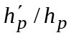 and compare it with the value of M; comment on the result.
(10 marks)

- Is the entire image of the post sharply in focus, i.e., is there any visible blurring? Explain your answer.
(7 marks)

- Describe how the image of the scene would be affected by increasing the focal length of the lens.
(4 marks)

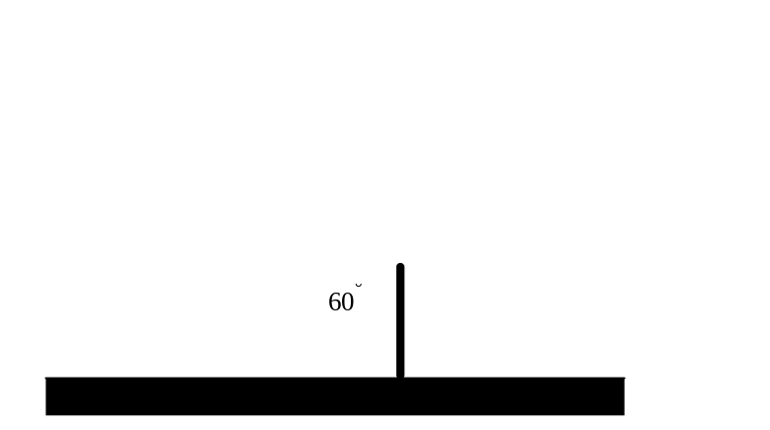

Figure 1

EE4212 Computer Vision / Page 3
Q.2

(a) One well-known method of threshold selection is based on the computation of a “global image statistic” (Kittler’s method).

- Describe the algorithm.
(5 marks)

- Consider a 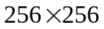 image consisting of a 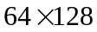 rectangular object (gray level 100) on a dark background (gray level 50). As shown in Figure 2(a), the sides of the rectangle are aligned with the sides of the image. Determine the exact threshold obtained using this algorithm. (Ignore the edge effects at the image boundary.)
(6 marks)

- Suppose zero-mean Gaussian noise of standard deviation 5 is added to the image. Would you expect the computed threshold value to remain the same, increase or decrease? Explain your answer.
(5 marks)

(b) What is the result of applying morphological thinning to the binary image of Figure 2(b)? (Employ symmetrical thinning.)

(9 marks)

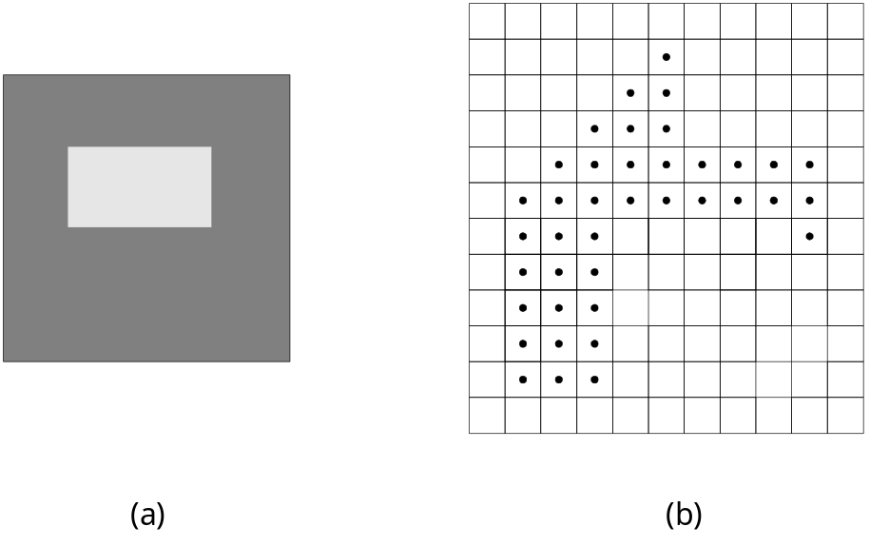

Figure 2
EE4212 Computer Vision / Page 4

Q.3

- How can a 3D point at infinity be described in homogeneous coordinates? Give the homogeneous coordinates of a 3D point at infinity in the direction of the Z axis. Convert the homogeneous point [3 4 2 1]^{T} to inhomogeneous coordinates.
(5 marks)

- In the “Shape from Texture” method proposed by Witkin, the underlying assumption is that the amount of contour (arc length) at different orientations is approximately the same. Briefly describe how this heuristic can be used to recover the tilt and slant of a surface oriented in 3-D.
(5 marks)

- Explain why, given a stereo pair of images and a point in one of the stereo images, its corresponding point must lie on a line in the second image.
(5 marks)

- What are the advantages and disadvantages of a large baseline in stereo imaging?
(5 marks)

- When a stereo pair of images is obtained in which the two cameras share the same x axis and have their y axes pointing in the same direction, then the epipolar line of a point in the left image is a row in the right image. Suppose, instead, that the second image in a stereo pair is obtained by moving the second camera forward by a distance h along the z axis of the coordinate system of the first camera. Now, if the center of the first image is at location (0,0) and the camera focal length is f, what is the epipolar line of a pixel at location (x,y)?
(5 marks)

EE4212 Computer Vision / Page 5

Q.4

- Suppose we have a camera that is undergoing a purely translational motion, and that the camera, with a focal length of 100, is moving with velocity (U,V,W) = (20, 30, 50). What is the location of the focus of expansion for this particular motion? What is the pattern of the optical flow vectors for this type of motion?
(5 marks)

- What is the aperture problem in computing optical flow? How does this aperture problem manifest itself in the Basic Brightness Constraint equation used by the differential technique for computing optical flow? Briefly describe one method to overcome such an aperture problem.
(6 marks)

- Consider the following phenomenon involving the perceived motion of “plaid” gratings created by superimposing two square wave gratings at different orientations. If a single grating is presented in motion, its perceived direction of movement is always perpendicular to the orientation of the stripes. If a second moving grating of the same spatial frequency and contrast is added to the first so that it moves in a different direction (Figure 4), the combined grating pattern is perceived to move in neither of the directions of the component gratings. Rather, it is seen to move in a direction midway between the two component motions. Why would you expect this?
(4 marks)

- When we perform a 3D reconstruction from motion flow, we can only ever determine the structure up to an unknown scale factor. Explain why this is so. Under perspective projection, can you recover 3D structure information from pure rotational flow?
(4 marks)

- State any three conditions under which the 2D motion field is different from the optical flow.
(6 marks)

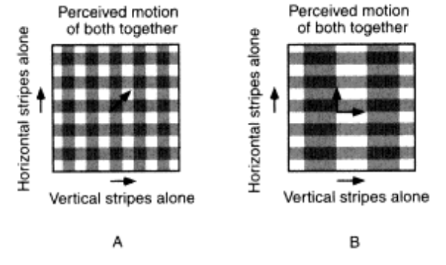
Figure 4

END OF PAPER

